Design a code for a simple calculator which takes input from the user and also details of what operation must be performed .The user can input only 2 operands

import java.util.Scanner;

public class calculator {

public static void main(String[] args) {

Scanner sc = new Scanner(System.in);

int op1,op2;

char oper;

System.out.println("enter one operand");

op1=sc.nextInt();

System.out.println("enter operator + - * or /");

oper=sc.next().charAt(0);

System.out.println("enter another operand");

op2=sc.nextInt();

int res=0;

switch(oper)

{

case '+' : res= op1 + op2;

break;

case '-' : res= op1 - op2;

break;

case '*' : res= op1 * op2;

break;

case '/' : res= op1 / op2;

break;

default: System.out.println("invalid operator");

System.exit(0);

break;

}

System.out.println("result = "+ res);

}

}

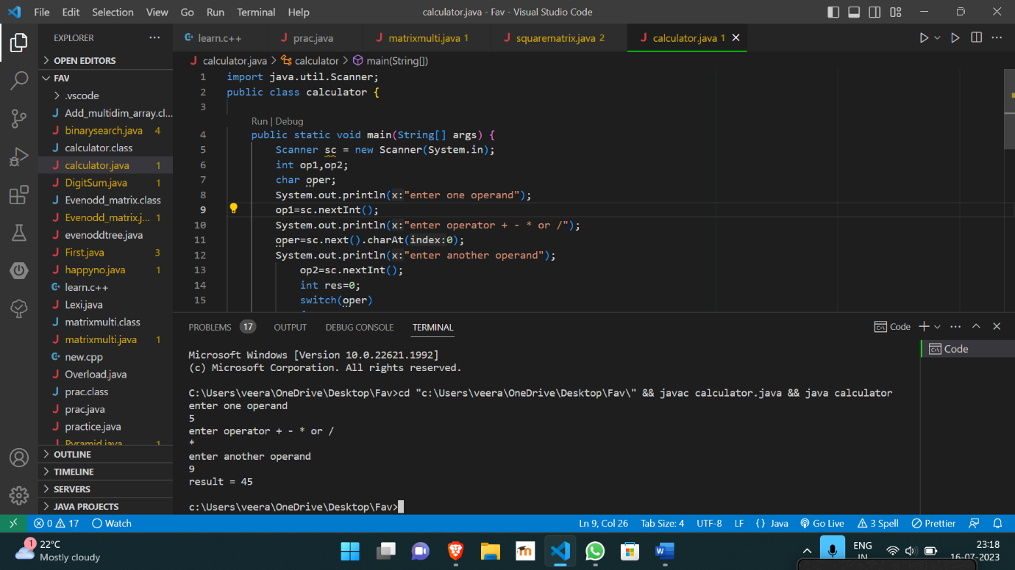

https://github.com/Veeragoutham04/Java_Lab/blob/main/Calculator